Introduction to Artificial Intelligence and Machine Learning

Dr Basel Barakat and Professor John Murray

University of Sunderland

# Aims of the workshop

This workshop dives into the world of Artificial Intelligence (AI) by equipping you with the necessary skills in two key areas.

Part 1: Introduction to Python Programming: We'll kick things off by building a solid foundation in Python. Python is a powerful and versatile programming language widely used in AI development due to its readability and extensive libraries.

Part 2: Developing AI Models: Once you're comfortable with Python, we'll move on to the exciting world of AI model development. You'll learn the fundamentals of creating AI models and gain hands-on experience bringing them to life.

**Feel free to discuss your work with peers, or with any member of the teaching staff.**

# Reminder

We encourage you to discuss the content of the workshop with the delivery team and any findings you gather from the session.

Workshops are not isolated, if you have questions from previous weeks, or lecture content, please come and talk to us.

Exercises herein represent an example of what to do; feel free to expand upon this.

Helpful Resources

The programming language that we will be using is Python which is a great for learning AI basics. In this workshop we will be using functions, lists, conditions and any other basic python commands. If you would like a refresh on these concepts you can check one of the following tutorials:

* **Overview of Python http://www.tutorialspoint.com/python/python_quick_guide.htm**
* **Good starting course https://www.tutorialspoint.com/python/python_overview.htm**
* Python Online Interactive http://www.learnpython.org/en/Hello%2C_World%21
* Python Hard Way http://learnpythonthehardway.org/book/ex20.html
* Python http://anh.cs.luc.edu/331/notes/PythonBasics.pdf
* Python <http://learnpythonthehardway.org/book/ex20.html>

The 2 courses in bold will be particularly useful if you are new to this coding environment.

To write the scripts we will be using Jupyter notebooks, which is a helpful IDE for writing the scripts. To download it, you can use the link below:

<https://realpython.com/jupyter-notebook-introduction/>

# Setting up the Jupyter notebook

**Click windows start button and type Jupyter Notebook**



**click 🡪 New | Python 3**

This will give you a new environment to start coding in python. We will be using this environment for the time being.

Now your PC is ready for programming 😊

**Part 1: Introduction to python**

Python is a general-purpose interpreted, interactive, object-oriented, and high-level programming language. It was created by Guido van Rossum during 1985- 1990.

Python 3 is available for Windows, Mac OS and most of the flavours of Linux operating system.

Python is Interpreted − Python is processed at runtime by the interpreter. You do not need to compile your program before executing it.

Python is Interactive − You can actually sit at a Python prompt and interact with the interpreter directly to write your programs.

Python is Object-Oriented − Python supports Object-Oriented style or technique of programming that encapsulates code within objects.

Python is a Beginner's Language − Python is a great language for the beginner-level programmers and supports the development of a wide range of applications from simple text processing to WWW browsers to games.

1. Use python to show a message on the monitor.

Please type the following command on your pc:

1. Use python as a simple calculator:

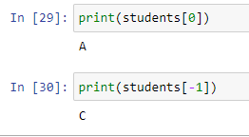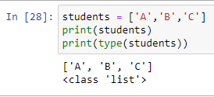

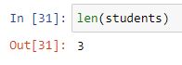

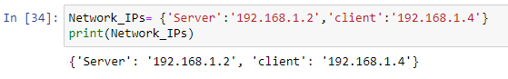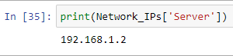

Loops: run the lines for *x* number of times. Two types (While and For)

While loop: keeps running the code until a condition is false

For loops: can be use to read the content of a list

A function is a block of code which only runs when it is called.

You can pass data, known as augments, into a function.

A function can return data as a result.

Function name

Function statement

Calling the function

Define a function to authenticate a user. The function would check if the user name and password are correct.

Pandas is an open-source, fast, powerful, flexible and easy to use open source data analysis and manipulation tool, built on top of the Python programming language.

|  |  |
| --- | --- |
| Function | Description |
| read_csv | Load delimited data from a file, URL, or file-like object; use comma as default delimiter |
| read_clipboard | Variation of read_csv that reads data from the clipboard; useful for converting tables from web pages |
| read_excel | Read tabular data from an Excel XLS or XLSX file |
| read_html | Read all tables found in the given HTML document |
| read_json | Read data from a JSON (JavaScript Object Notation) string representation, file, URL, or file-like object |

* Printing top five rows
* Printing bottom five rows
* Printing a column
* Showing the number of rows

Descriptive statistics

Scikit-learn is a free software machine learning library for Python. It features various classification, regression and clustering algorithms including support-vector machines, random forests, gradient boosting, k-means and DBSCAN, and is designed to interoperate with the Python numerical and scientific libraries NumPy and SciPy.

Using the missing data spreadsheet. Let us use this data to build a model that can predict the wight (dependent viable) using the blood pressure and the age (independent variables).

1. Prepare the data frame using pandas
2. Define the independent variable as X, and the dependent viable as y
3. Split the data into training and testing

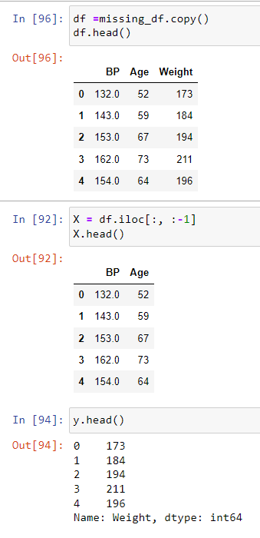

* Train the Model using the training data
* Predict using the test data
* Show the original values and the predicted ones

To evaluate the prediction accuracy, we will use:

1. Coefficient of determination ($R^{2}$)

$R^{2}$ is the proportion of the variation in the dependent variable that is predictable from the independent variable(s). Its best value is 1

2. Root mean square error (RMSE)

RMSE is the average distance between the predicted values from the model and the actual values in the dataset.

